SentinelShield

Advanced Intrusion Detection & Web Protection System
Practical Work Documentation

RISHABH KUMAR
B.Tech, Computer Science & Engineering
Graphic Era University, Dehradun

1. What this project is and why I built it this way

SentinelShield is a Web Application Firewall (WAF) I built to actually understand how intrusion detection works, instead of just reading about SQL injection and XSS in theory. The idea was to build something that behaves like a real WAF — not a toy that just prints 'attack detected' — but something that sits in front of an actual running web application, inspects real HTTP requests, and makes a real decision about each one: let it through, or block it.
I deliberately kept the demo app simple (four endpoints: home, login, search, file) because the point of the exercise wasn't to build a complicated website — it was to build a realistic surface for testing detection logic, the same way a security student might set up a deliberately simple target to practice against.
There are four moving pieces in total: the demo app (the thing being 'attacked'), the detection engine (checks the content of each request and how frequently a given IP is hitting the server), a logging layer (writes down what happened, permanently), and a dashboard (shows all of it visually instead of me having to read the raw log file every time). I built them in that order — bottom-up — because each one depends on the last: there's no point building a dashboard before there's any data being logged, and no point logging before there's actually a decision being made about each request.

2. Concepts I had to understand first

2.1 What's actually inside an HTTP request
Before this project I hadn't really thought about what happens mechanically when you type something into a search box or hit login. Every request has a few distinct parts: the URL/path (which page or endpoint), query parameters (the stuff after the '?' in a URL, like ?q=laptop), headers (metadata like which browser sent it, or what page linked here), and the body (used mainly for form submissions, like login credentials sent through a POST request).
Any of these parts can carry an attack. For this project I focused specifically on query parameters and form body data, since that's where the endpoints I built actually accept user input — /search takes a query parameter, /file takes one too, and /login takes form data. I didn't check headers in this version, which I've flagged later as a real limitation, since headers like User-Agent can technically be forged and used to smuggle payloads too.

2.2 The five attack types, in more depth

SQL Injection

A lot of web apps build their database queries by directly inserting whatever the user typed into a query string. A simplified login check might work like this internally: SELECT * FROM users WHERE username='<input>' AND password='<input>'. If you type a normal username, this works fine. But if you type admin' OR '1'='1 as the username, the query becomes: SELECT * FROM users WHERE username='admin' OR '1'='1' AND password='...'. Since '1'='1' is always true, the OR makes the whole condition true regardless of the password, and — depending on how the app is written — this can let someone log in without ever knowing a real password.
This is exactly the payload I used to test my own /login endpoint. My detector doesn't try to 'understand' SQL — it just looks for the raw ingredients that make this attack possible: a single quote (which breaks out of the intended string), SQL comment markers like -- or # (used to cut off whatever query text comes after, so it doesn't cause a syntax error), and keywords like UNION SELECT (used to combine a second, attacker-controlled query with the original one) or DROP TABLE / INSERT INTO (used to modify or destroy data directly).

XSS — Cross-Site Scripting
This happens when a page shows back whatever a user typed, without cleaning or escaping it first. Say a search page displays 'Results for: <whatever the user searched>'. If the app just inserts that text into the HTML directly, and the user searches for <script>alert(1)</script>, the browser doesn't see that as text — it sees an actual <script> tag and runs it. In a real attack, instead of alert(1), the script would usually try to steal the session cookie or redirect the victim to a fake login page.
There's actually more than one kind of XSS — reflected (the attack is in the URL/request itself and reflected straight back, which is what I tested), and stored (where the payload gets saved in a database and served to every future visitor, which is more dangerous but wasn't something my simple demo app persists any data for). My detector checks for <script> tags, but also for less obvious tricks like onerror= or onclick= inside other tags — for example <img src=x onerror=alert(1)> runs JavaScript the moment the broken image fails to load, without ever using the word 'script'.

LFI — Local File Inclusion

Some endpoints accept a filename and use it to open a file on the server — for example, an endpoint that serves help documents by filename: /file?name=readme.txt. If the app doesn't restrict this to one specific folder, an attacker can ask for a completely different file, potentially one containing sensitive information, like /etc/passwd on Linux (which lists system user accounts) or win.ini on Windows (a basic system config file, useful mainly as a 'proof it worked' target since it's harmless but proves arbitrary file reads are possible).
My rules specifically watch for these well-known filenames, on the logic that a legitimate use of a /file endpoint would essentially never need to reference operating system internals.

Directory Traversal

This is the mechanism that actually makes LFI possible. Using ../ moves up one directory level; repeating it lets you climb out of whatever folder you're supposed to be confined to and reach anywhere else on the filesystem. So ../../../../windows/win.ini says 'go up four folders, then into windows, then open win.ini' — regardless of how deep the app's intended file folder actually was.
I specifically check for two or more repetitions of ../ (or its Windows equivalent, ..\) rather than just one, because a single ../ can genuinely appear in a normal, harmless file path. Two or more in a row is a much stronger and more deliberate signal.

Command Injection
This applies when user input ends up being passed into a system shell command somewhere in the app — for instance, an app that uses a filename in a command-line tool to convert or process it. Shell operators like ; (run the next command regardless), | (feed this command's output into the next one), and && (run the next command only if this one succeeds) let an attacker chain on something extra. So if an app runs a command using unescaped user input and someone submits test;whoami, the shell runs the intended command with 'test', then separately runs whoami — revealing the server's current OS user.
My detector looks for these chaining characters sitting immediately next to common system commands (whoami, cat, ls, dir, ping, curl, wget, and a few others), plus backticks and $(...) syntax, both of which are ways to run a command and substitute its output directly into another command in Unix shells.

2.3 Why content-checking alone isn't enough — rate limiting and behaviour
None of the five rules above would catch a brute-force login attempt, because none of the individual passwords being guessed look malicious by themselves — 'password123' isn't an attack pattern. What actually gives away a brute-force attempt is the volume and speed: a real person doesn't try 500 passwords in 10 seconds, but a script can easily do that.
So separate from the regex checks, SentinelShield tracks how many requests each IP address makes within a rolling time window. I set this to 15 requests per 10 seconds — a threshold I picked by testing manually and seeing what a normal amount of clicking around felt like versus an obvious flood. If an IP crosses that threshold, it gets blocked with an HTTP 429 (Too Many Requests) until enough time passes for its recent request count to drop back under the limit.
This is a genuinely different kind of detection from the signature matching — one looks at what's inside a single request, the other looks at the pattern across many requests over time. Real WAFs run both kinds of checks for exactly this reason; content-based rules and behaviour-based rules catch different categories of abuse.

2.4 Why I log everything, and why in this specific format
Every decision the system makes — allowed or blocked, and why — gets written to a file called sentinel_log.jsonl, with one JSON object per line (a format usually called JSON Lines, or JSONL). I chose this over one big JSON array mainly for a practical reason: appending a new line to a file is simple and safe, but appending to a JSON array means reading the whole file back in, adding to it, and rewriting the entire thing — which gets slower and riskier as the file grows, and briefly makes the file invalid JSON while it's being rewritten.
Each entry has exactly five fields: timestamp, IP, path, verdict, and category. I kept it deliberately minimal — enough to reconstruct what happened and when, without so many fields that the log becomes hard to skim manually, since being able to open the file and read it directly (not just through the dashboard) was one of the practical requirements.

2.5 Why a dashboard, not just the log file
Reading raw .jsonl lines is fine when you're debugging one specific thing, but it's genuinely tedious for getting an overall sense of what's going on — especially once the file has 90+ entries in it, like mine does now. The dashboard pulls from the exact same underlying data (through two small API endpoints, /api/logs and /api/flagged) but presents it as running totals, a chart broken down by attack category, and a table of the most recent events, refreshing automatically every 5 seconds.
I built the dashboard with a dark, terminal-style theme rather than a typical light 'admin panel' look, since that's closer to what real security monitoring tools (SOC dashboards, SIEM consoles) actually look like — dense, dark, and built for scanning quickly, not for looking pretty.

ARCHITECTURE

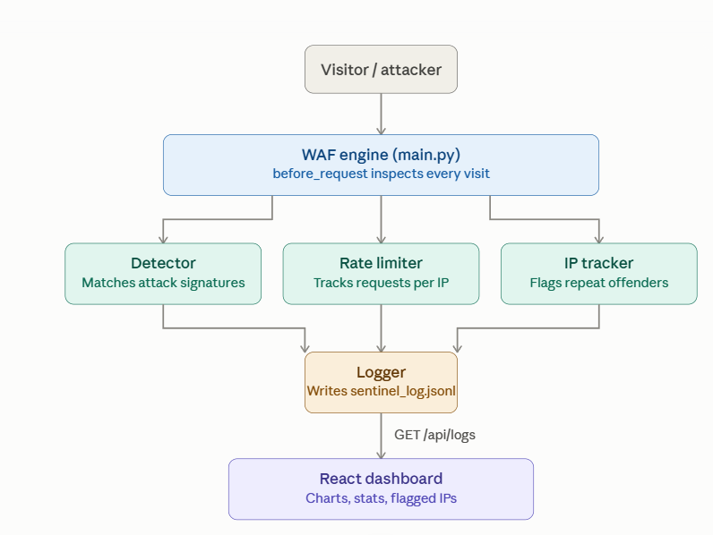

DECISION FLOW

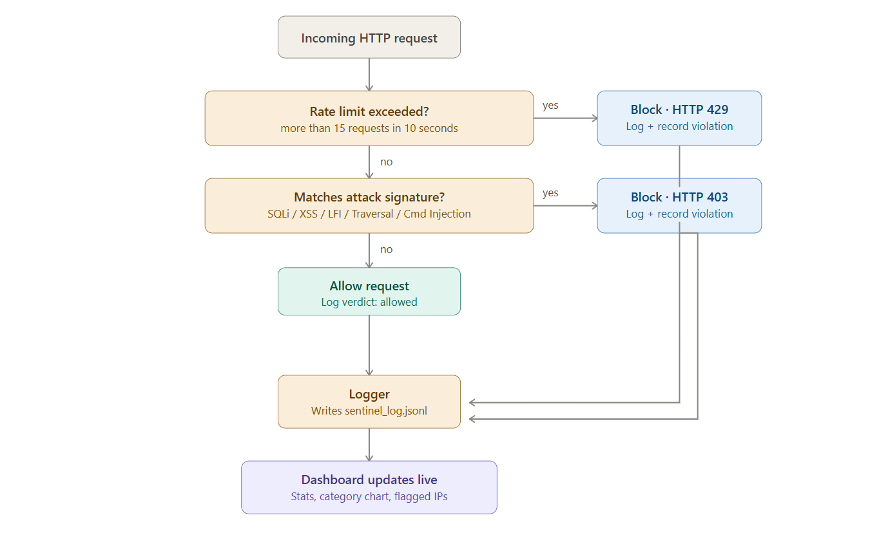

3. How the code is organized, file by file
The project is split into two top-level folders: main-app (the demo website being protected) and core-engine (everything that does the actual detection, tracking, and logging), plus a separate dashboard folder for the React frontend. Below is what each file does and, where it's useful, the actual code.

3.1 main.py — ties everything together
This is where the demo app's routes live, and also where the WAF check itself happens, using Flask's before_request decorator — meaning the function below runs before every single route, regardless of which one is being hit.

@app.before_request
def waf_check():
if request.path.startswith("/api/"):
return
ip = request.remote_addr
path = request.path
if is_banned(ip):
log_event(ip, path, "blocked", "Banned IP")
abort(403)
if check_rate_limit(ip):
log_event(ip, path, "blocked", "Rate Limit Exceeded")
record_violation(ip, "Rate Limit Exceeded")
abort(429)
values_to_check = list(request.args.values()) + list(request.form.values())
for value in values_to_check:
category = inspect_input(value)
if category:
log_event(ip, path, "blocked", category)
record_violation(ip, category)
abort(403)
log_event(ip, path, "allowed")
The order of these checks matters. Banned IPs are rejected first, before spending any time on rate limiting or regex matching, since there's no point analysing a request from a source that's already confirmed malicious. Rate limiting comes next, since it's a cheap check (just comparing counts), before the more expensive job of running every submitted value through every regex pattern.

3.2 detector.py — the actual rule set
This file defines five lists of regex patterns, one per attack category, collected into a dictionary so they can all be checked in a loop:

RULE_CATEGORIES = {
"SQL Injection": SQLI_PATTERNS,
"XSS": XSS_PATTERNS,
"LFI": LFI_PATTERNS,
"Directory Traversal": TRAVERSAL_PATTERNS,
"Command Injection": CMD_INJECTION_PATTERNS,
}
def inspect_input(value):
if not value:
return None
for category, patterns in RULE_CATEGORIES.items():
for pattern in patterns:
if re.search(pattern, value, re.IGNORECASE):
return category
return None
inspect_input() returns the category name the moment something matches, rather than checking every remaining pattern — there's no benefit to knowing a request matches two different attack types, since it's getting blocked either way. Matching is case-insensitive (re.IGNORECASE) since capitalisation tricks like SeLeCt are a real, if basic, evasion technique.

3.3 limiter.py — behaviour tracking, short-term

REQUEST_WINDOW = 10
REQUEST_THRESHOLD = 15
ip_request_log = {}
def check_rate_limit(ip):
now = time.time()
if ip not in ip_request_log:
ip_request_log[ip] = []
ip_request_log[ip] = [t for t in ip_request_log[ip] if now - t < REQUEST_WINDOW]
ip_request_log[ip].append(now)
return len(ip_request_log[ip]) > REQUEST_THRESHOLD
The list comprehension is the important part — every time this function runs, it first throws away any timestamps older than the window before adding the new one and checking the count. Without that cleanup step, an IP's request count would only ever grow, and it would eventually get permanently blocked after enough total traffic, which isn't the intended behaviour — I only want to catch sustained, current abuse, not punish an IP forever for something that happened an hour ago.
This state lives only in memory (a plain Python dictionary), which means it resets if the server restarts. I know this is a limitation for a production system, but it's a reasonable and common approach for a small, single-process app like this one.

3.4 logger.py — writing the log file

def log_event(ip, path, verdict, category=None):
entry = {
"timestamp": time.strftime("%Y-%m-%d %H:%M:%S"),
"ip": ip,
"path": path,
"verdict": verdict,
"category": category,
}
with open(LOG_FILE, "a") as f:
f.write(json.dumps(entry) + "\n")
Opening the file in append mode ("a") rather than write mode ("w") is what makes this safe to call repeatedly without ever losing previous entries — every call adds one new line at the end and leaves everything before it untouched.

3.5 ip_tracker.py — behaviour tracking, long-term
This is separate from limiter.py on purpose. The rate limiter only remembers the last 10 seconds; this file remembers an IP's entire violation history, stored persistently in ip_tracker.json rather than just in memory.

FLAG_THRESHOLD = 3
BAN_THRESHOLD = 10
def record_violation(ip, category):
data = _load()
if ip not in data:
data[ip] = {"violation_count": 0, "categories": [], "status": "clean", ...}
data[ip]["violation_count"] += 1
data[ip]["categories"].append(category)
if data[ip]["violation_count"] >= BAN_THRESHOLD:
data[ip]["status"] = "banned"
elif data[ip]["violation_count"] >= FLAG_THRESHOLD:
data[ip]["status"] = "flagged"
_save(data)

I picked 3 and 10 as the thresholds somewhat arbitrarily, based on what felt reasonable for a small demo — in a real system these would likely be tuned based on actual traffic data rather than guessed.

3.6 The dashboard (App.jsx)
The dashboard polls both API endpoints every 5 seconds using setInterval and the browser's fetch():

useEffect(() => {
fetchData();
const interval = setInterval(fetchData, 5000);
return () => clearInterval(interval);
}, []);
From the raw list of log entries, the component works out totals, groups blocked entries by category (for the bar chart), and takes the most recent 20 events for the table, reversing the order so the newest entries appear first. The flagged-IP data gets displayed in its own separate table, with a status badge (flagged/banned) so it's visually obvious at a glance.

4. How I actually tested it

I didn't want to just claim the detection rules work — I wanted to actually try to break the system myself, the same way the practical brief describes. I used curl from the terminal rather than only clicking through a browser, mainly because curl makes it easy to send exact payloads, including POST requests with a body, without worrying about a browser auto-encoding or blocking anything on its own.

4.1 Baseline — normal traffic first
Before testing any attacks, I first confirmed the app worked normally: visiting the homepage, and searching for an ordinary word like 'laptop'. Both came back with a normal 200 response and no blocking — this matters because it establishes that the WAF isn't just blocking everything by default, which would make the whole exercise meaningless.

4.2 One payload per attack category
I then sent one deliberately crafted payload per category, each targeting the specific endpoint where that kind of input made the most sense (login for SQLi, search for XSS and command injection, file for LFI and traversal):
What I sent | Payload | Endpoint | What happened | Status
SQL Injection | username=admin' OR '1'='1 | /login (POST) | Blocked | 403
XSS | <script>document.cookie</script> | /search | Blocked | 403
LFI | ../../etc/passwd | /file | Blocked | 403
Directory Traversal | ../../../../windows/win.ini | /file | Blocked | 403
Command Injection | test;whoami | /search | Blocked | 403
Brute force (20 rapid requests) | 20 login attempts, under a second apart | /login (POST) | First 15 went through, rest were blocked | 429
Normal request | q=laptop | /search | Allowed | 200
Normal request | GET / | / | Allowed | 200

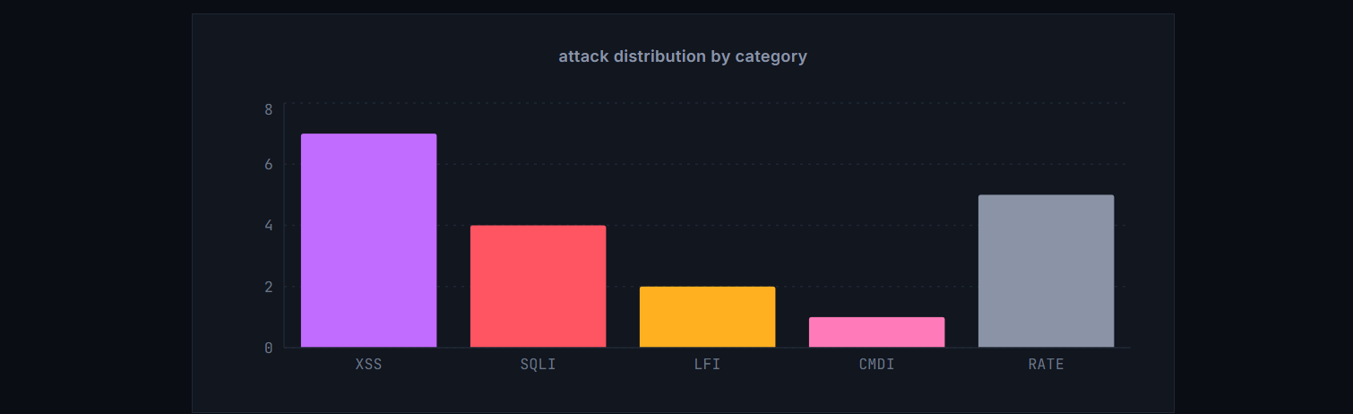

4.3 Brute-force simulation
For the rate limiter, I used a PowerShell loop to fire 20 login attempts in rapid succession, each with a different fake password, simulating what an automated password-guessing script would look like:
for ($i=1; $i -le 20; $i++) {
curl.exe -X POST http://127.0.0.1:5000/login -d "username=admin&password=guess$i"
}
The first 15 came back as normal login attempts; the remaining 5 came back as 429 Too Many Requests, matching the configured threshold exactly.

4.4 Testing the flagging system
To check the longer-term IP tracking, I repeated the SQL Injection payload three times in a row against /login. After the third attempt, querying /api/flagged directly showed my own IP marked as 'flagged', with a violation count of 3 and all three attempts logged under the SQL Injection category — confirming the escalation logic worked as designed

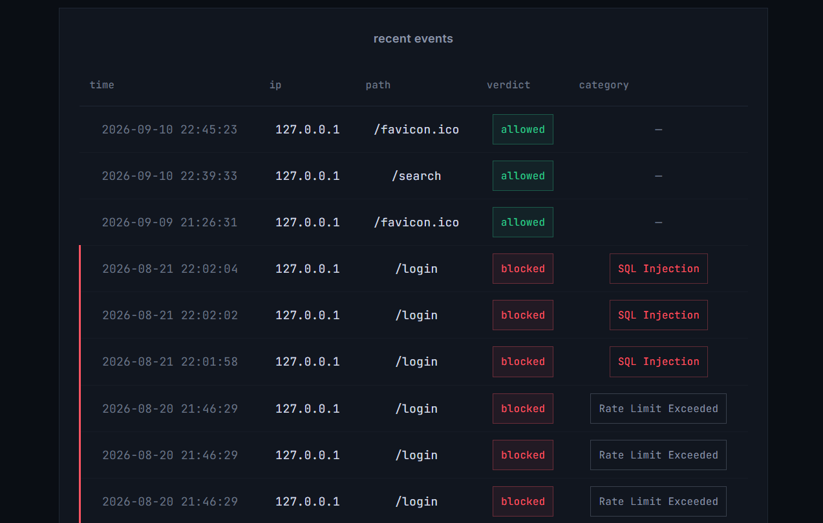

4.5 What the logs showed afterward
Going through sentinel_log.jsonl after all this testing, a few things stood out: every category matched correctly with nothing misclassified into the wrong bucket; the rate limiter let exactly the first 15 requests through and started blocking from #16, lining up with the configured threshold; and repeating the SQLi payload three times correctly escalated my IP to 'flagged'. Nothing I sent as a normal request was ever blocked, so — at least for what I tried — there were no false positives.

5. Results and analysis

Metric | Value
Total requests logged | 96
Requests blocked | 19
Requests allowed | 77
Block rate | ~20%
Attack categories triggered | SQL Injection, XSS, LFI, Command Injection, Rate Limit Exceeded
IPs flagged | 1 (127.0.0.1 — hit 3 SQL Injection attempts)
False positives seen | None
False negatives seen | None, for the payloads I actually tried

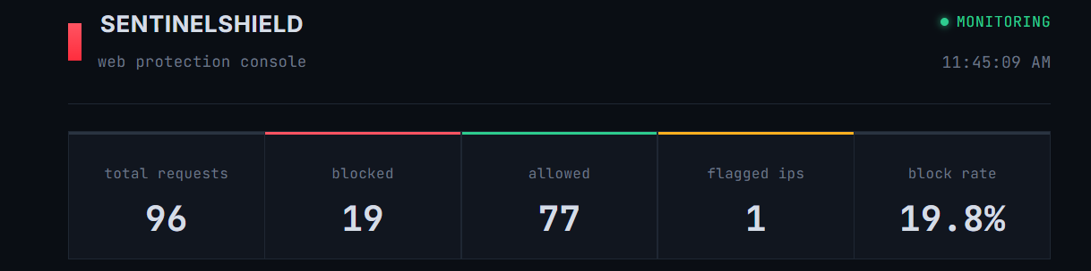
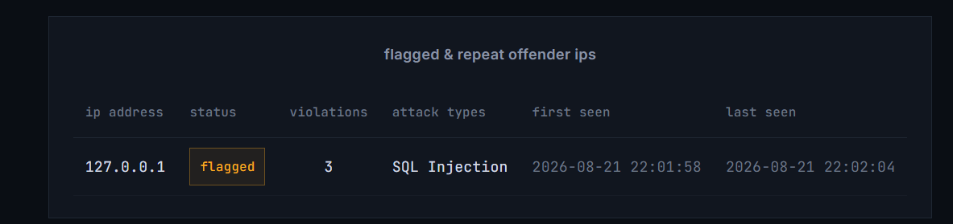

5.1 How accurate was it, really?
Every attack payload I tried was blocked, and every normal request I tried got through — 100% against the specific things I tested. I want to be upfront that this isn't the same as saying it would catch everything a real attacker might try. It's accurate against known, textbook-style payloads that match the exact patterns I wrote rules for — not against someone actively trying to find gaps in this specific rule set, which is a very different and much harder problem.

5.2 False positives and false negatives
No false positives showed up — nothing normal ever got blocked during testing. No false negatives either, but only for what I actually threw at it. Going in, I already know there are gaps:
- Double-encoded or obfuscated payloads probably wouldn't be caught, since the check is a single regex pass over the raw value, not a decode-then-check step.
- Headers like User-Agent or Referer aren't checked at all right now — only URL parameters and form fields are.
- If an attack were split across two different parameters, neither half alone would trigger anything, since each value is checked independently rather than the request as a whole.
- The regex patterns are reasonably specific, which keeps false positives low, but the same specificity means a slightly reworded payload that doesn't match the exact pattern could slip through.

5.3 Patterns I noticed
- Content-based attacks consistently got a 403, and rate-based abuse consistently got a 429 — the two detection layers are clearly doing different, non-overlapping jobs.
- The IP flagging system is really what separates someone poking around once from someone being persistent — a single blocked request doesn't tell you much on its own, but three in a row from the same IP is a much stronger signal.
- The dashboard's own background polling (fetching /api/logs every 5 seconds) shows up in the total request count, so anyone analysing this data for real would need to filter that out first — it's monitoring traffic, not attacker traffic, and mixing the two would distort the numbers.

5.4 What I'd improve if I kept working on this
- Actually check headers too, not just URL and form data — a more complete WAF would inspect the whole request, not just the parts I chose to focus on.
- Use some kind of severity score instead of an instant block, so a request with one mildly suspicious character isn't treated identically to an obvious, multi-signature attack.
- Move the regex rules into a separate config file (JSON or YAML) instead of hardcoding them directly in detector.py, so rules could be updated without touching the code — this is genuinely how production WAFs like the OWASP Core Rule Set are structured.
- Rate-limit per endpoint instead of using one global number for the whole app — a login page arguably needs a stricter limit than a search box, since the consequences of a successful brute-force are much higher.
- Persist the rate limiter's state somewhere other than memory, so it survives a server restart the same way the IP tracker's data already does.

5.5 Conclusion
This project gave me an actual working version of the core ideas behind a real WAF: inspecting requests, matching known attack signatures, watching for abusive behaviour over time, logging every decision permanently, escalating repeat offenders, and visualising all of it on a live dashboard. It's obviously far simpler than something like Cloudflare's or AWS's WAF, but the underlying approach — pattern matching plus behavioural tracking — is genuinely the same idea those tools use, just running at a much smaller scale and against a much smaller, hand-written rule set.

